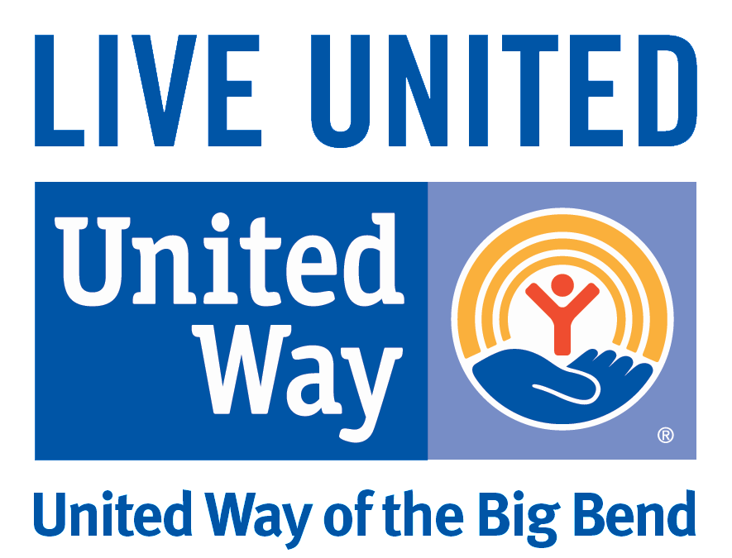
Workplace Campaign Best Practices

- Campaign Time Line
  - Select a two week period between August and early December to facilitate your workplace campaign. Earlier will provide you more lead time for your payroll department to process payroll deduction information. *Option: Participate in a Frontrunner/Pacesetter Campaign.

- Campaign Goal
  - Set a campaign goal of 10% to 20% increase over last year – work with United Way staff or Loaned Executives on ways to reach your goal.
  - Ask members of your leadership team/executive management to consider giving a Leadership Gift.
  - Ask employees who currently donate to consider giving $1 more per pay period. Ask employees who do not already give, to donate $1 per pay period. Let them know that every dollar makes an impact. Include criteria for goal setting: S.M.A.R.T. (Specific, Measurable, Attainable, Relevant, and Timely).

- Personalize United Way Pledge Forms
- Ask your HR or Payroll Department to help personalize pledge forms with employee contact information.

- Hold Campaign Kickoff Event or Kickoff Day
- Encourage Employees to make their gift on the Kickoff Day!
- Ask United Way staff for ideas on how best to kickoff your campaign or create awareness. *See FUN-Raising Guide
- Tag United Way of the Big Bend in photos of your campaign kickoff events on social media, with you celebrating your donors, etc.

- CEO and Campaign Team Follow Up
- Ask your CEO or members of your campaign team to join you in sending follow up emails to employees after distributions of pledge forms.
- Provide incentives. For multiple incentive or raffle drawings, encourage employees to return their pledge early to be eligible for more giveaways. (Raffle prizes could include parking spaces near building, 1 hour or more paid time off work, lunch with the CEO, gift certificates, etc.) *Must involve CEO/Executive team in this, you will need their approval.
- Facilitate special events (e.g. Dress Down Days) to create awareness and raise funds
- Use a graph or pie chart to keep employees updated about your internal campaign status. *Be sure to visit uwbb.org/ECC-Resource for tips, tools, etc.

- Campaign Deadline Update
- Send reminder email letting employees know deadline to return completed pledge forms and eligibility for raffle drawings/prizes.
- Ask UWBB staff or Loaned Executive for facts or success stories that can be included in these updates. *Be sure to visit uwbb.org/ECC-Resource for tips, tools, etc.

- Campaign Paperwork Collection
- Place a copy of the pledge forms, and any money into a Campaign Envelope. Multiple Envelopes can be provided if necessary. Submit your completed envelope to UWBB employee or Loaned Executive. If you have separate “Special Event” money, please place that in a separate envelope and label it.
- Do NOT leave cash or checks in your desk drawer or car overnight.
- Turning in multiple envelopes throughout your campaign is encouraged so cash and checks do not sit. Just mark “Partial” on your campaign envelope and turn it in.

- Thank You Event/Campaign Finale Communication
- Hold a thank you event or thank you day to create awareness of employee support and impact.
- Invite a representative from UWBB or Loaned Executive to attend.
- Tag United Way of the Big Bend in your Celebration photos. Use hash tag #LiveUnited #UWBB #community
- Attend United Way’s Finale Celebration and receive your plaque or certificate of support.

- Support United Way Year Round
- Coordinate a team of employees to participate in a volunteer project
- Encourage your employees to volunteer in the following ways:
  - Campaign Team Member
  - Investment Team Member
  - VITA Volunteer
  - Reading/Math Pal
  - Women United group
  - Young Leaders Society
  - Loaned Executive

