Workplace Campaign Thank You

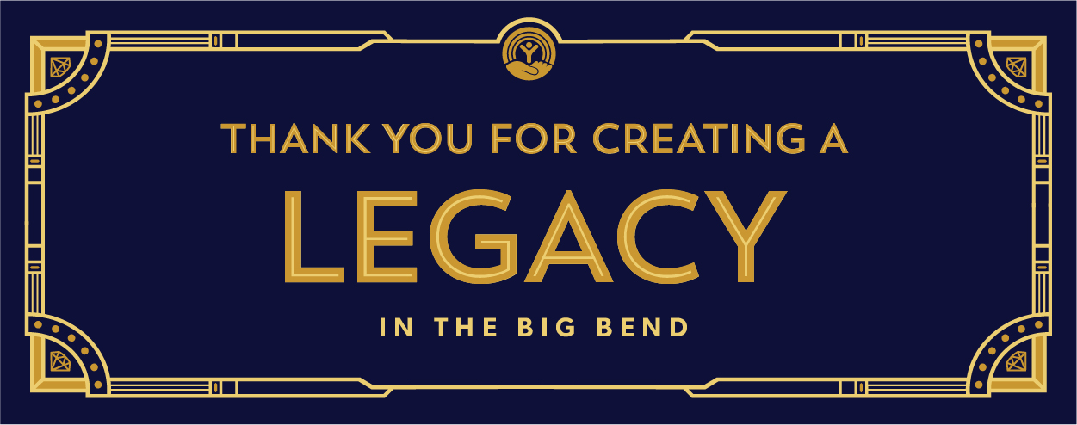

Dear [Company Name] team,

Thank you for investing in United Way of the Big Bend. Our workplace campaign was a great success because of our staff’s generosity. We have undoubtedly created a legacy that will make our community safer, healthier and stronger.

Your investment is going to make a real difference in the lives of people in our community in the days, weeks and months ahead. Because of your generosity, children across our community will be given dental care for possibly the first time in their life; elderly shut-ins will be delivered healthy meals and children who are struggling with reading and math in our community will be given a helping hand and a mentor to help them achieve success.

Thank you not only for your generosity and support, but also for showing our community how much [Company Name] cares.

I am so proud to have created a legacy with you where we LIVE UNITED!
[Name]

